

Lab No. 10

Mehran University of Engineering and Technology Shaheed Zulfiquar Ali Bhutto Campus, Khairpur Mir’s Department of Software Engineering

**Course: Operating System SW-225 (Practical) - Instructor: Engr. Shamshad Naveed**

**Objective: Getting Familiar with Ubuntu GUI**

|  |  |  |  |  |
| --- | --- | --- | --- | --- |
| **Name:** | **Mohammad Saleem** | **Roll Number:** | | **K20SW033** |
| **Score:** | **Signature:** | **Date:** | **18/10/2022** | |

|  |  |  |  |  |  |  |  |
| --- | --- | --- | --- | --- | --- | --- | --- |
| **LAB PERFORMANCE INDICATOR** | SUBJECT KNOWLEDGE | DATA ANALYSIS AND INTERPRETATION | ABILITY TO CONDUCT EXPERIMENT | PRESENTATION | CALCULATION AND CODING | OBSERVATION  /RESULTS | SCORE |
|  |  |  |  |  |  |  |  |

**Task :** Getting Familiar with Ubuntu GUI

* Here is the main interface of Ubuntu GUI

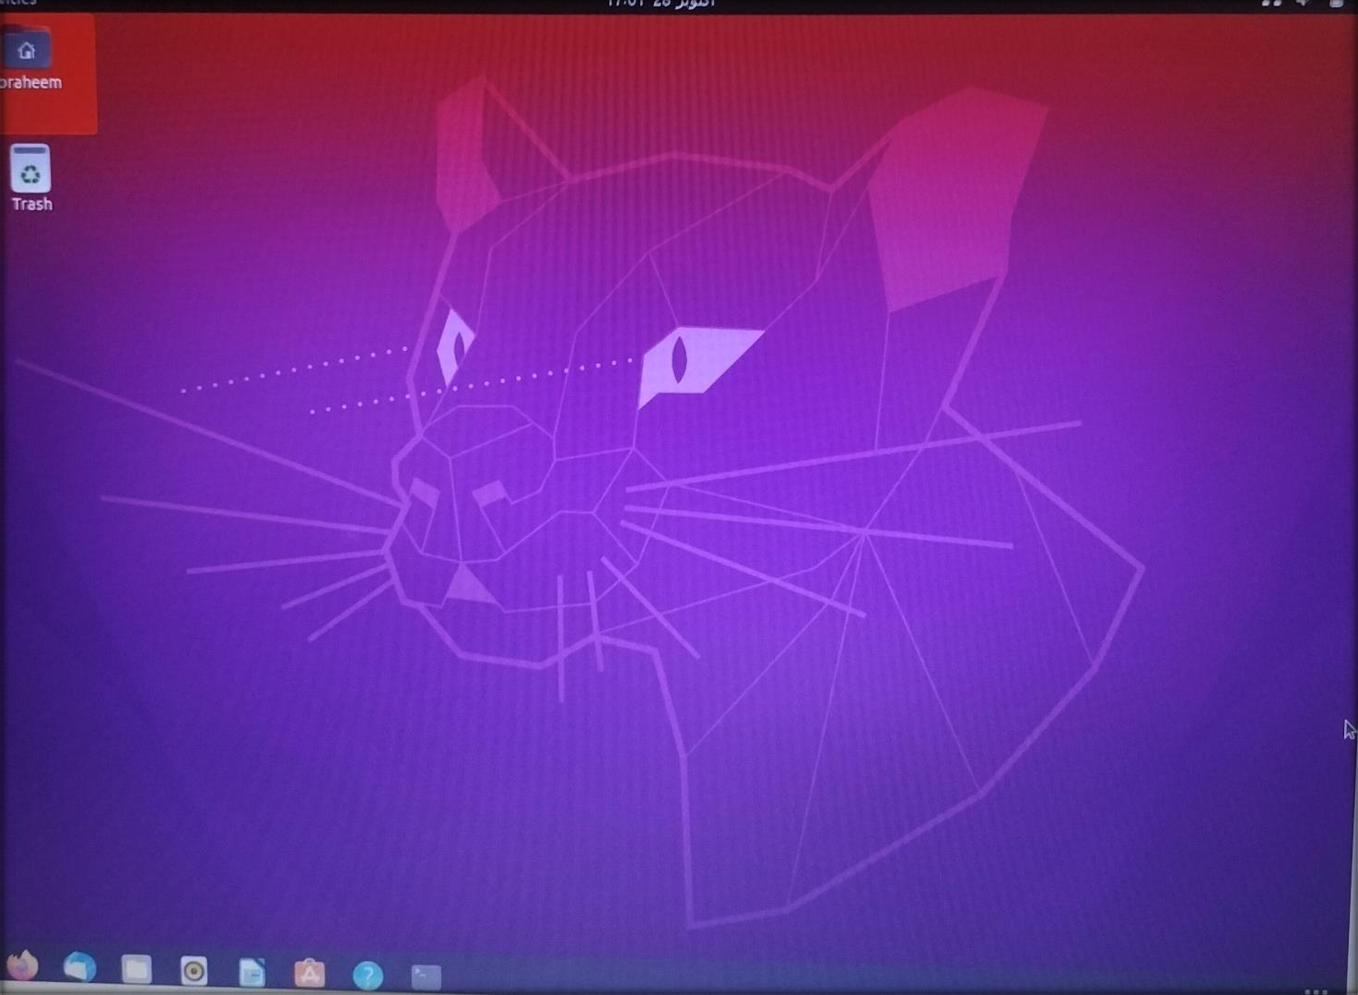

This appearance section in Ubuntu

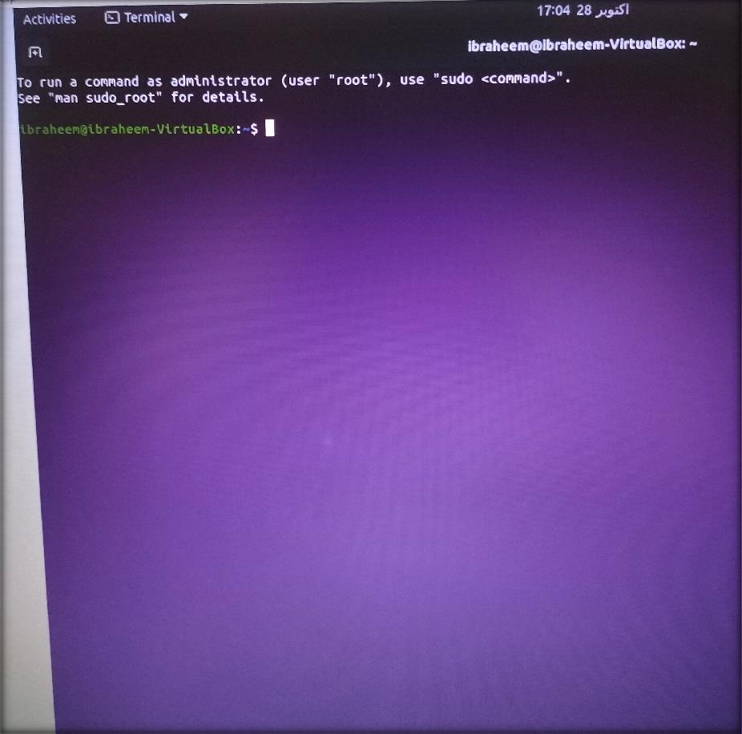

* **This is home section of Ubuntu**

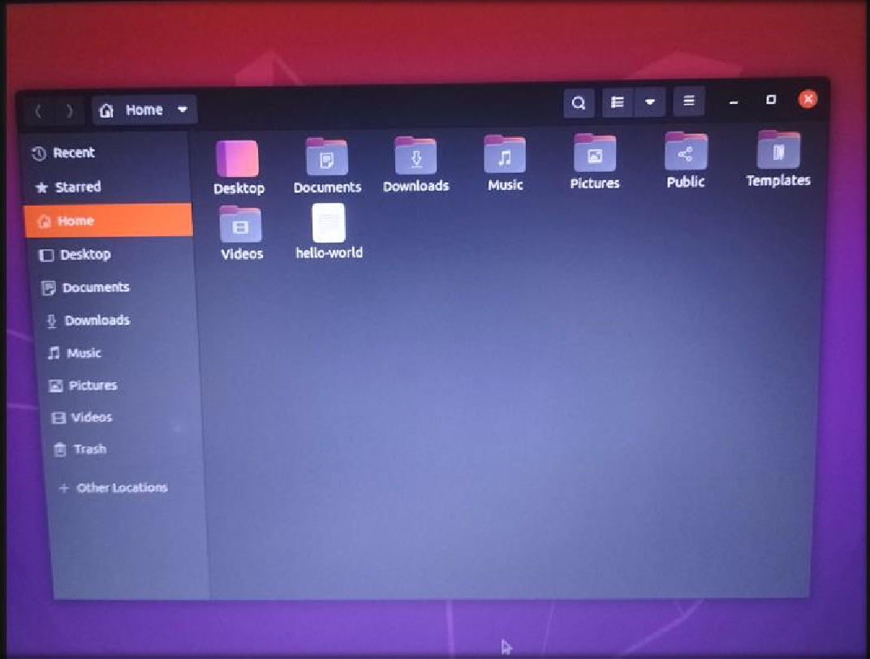

These are setting options in Ubuntu

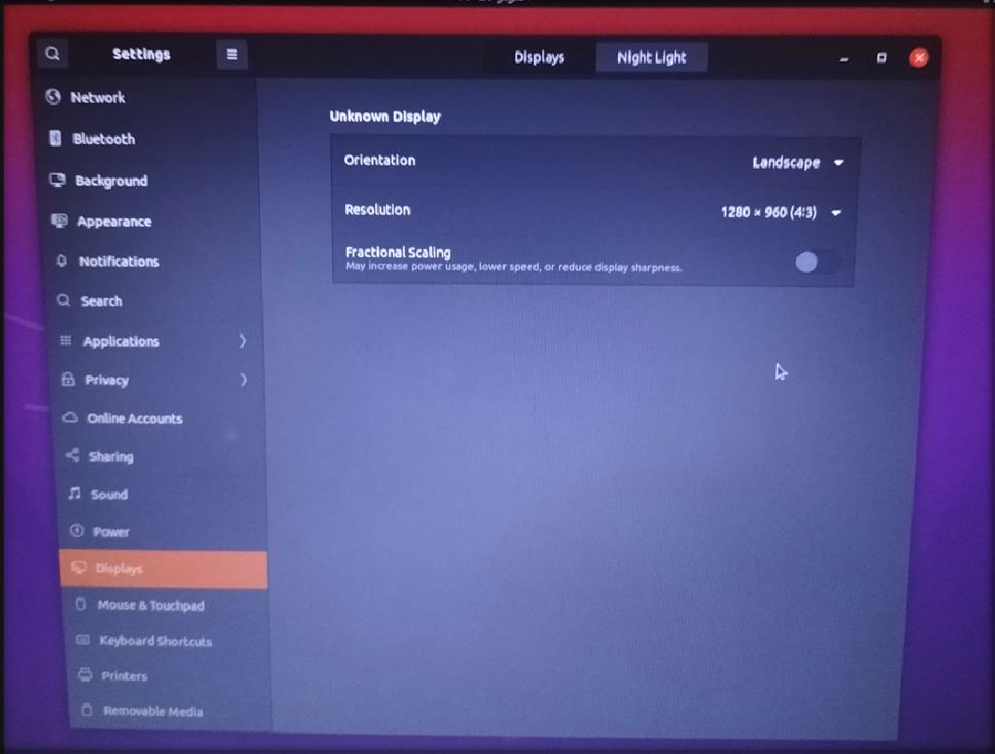

* **These are keyboard shortcuts of Ubuntu**

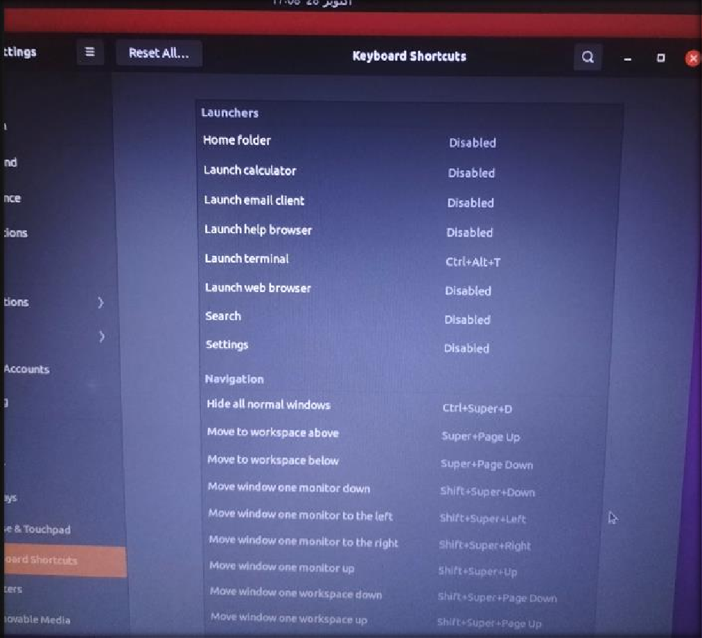

➢ This appearance section in Ubuntu

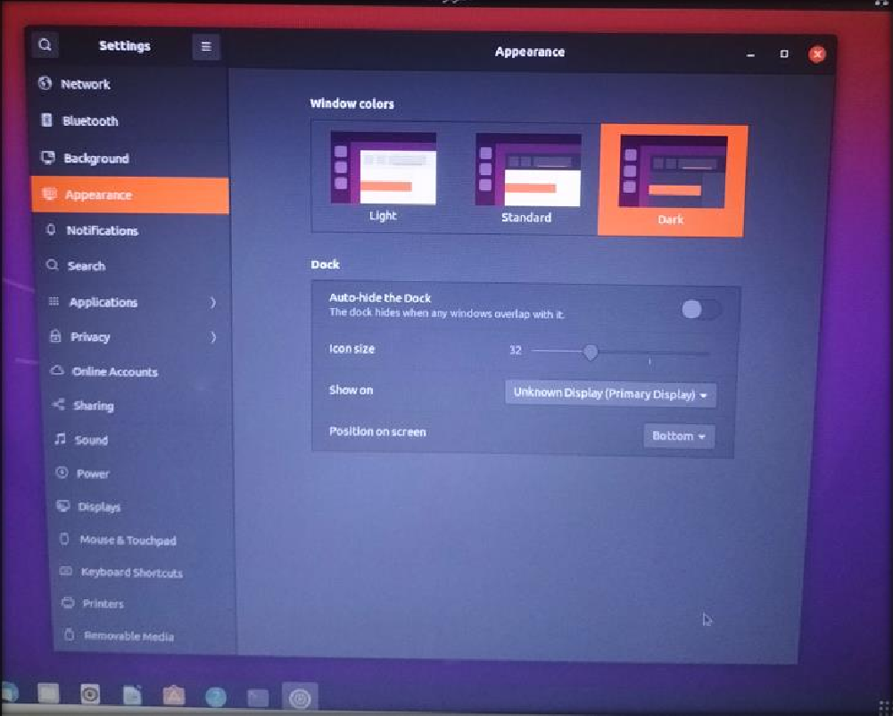

* **This is Web Browser in Ubuntu**

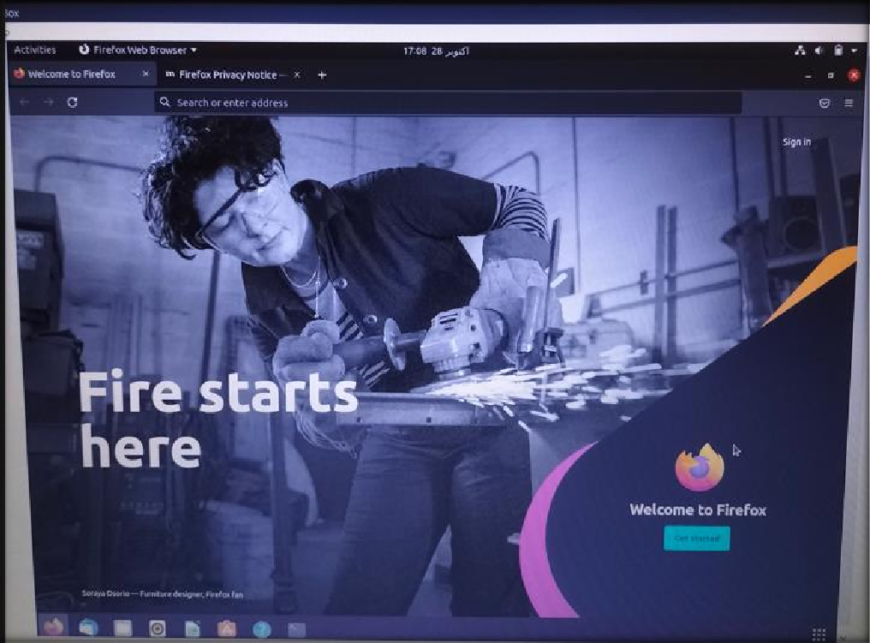

This is Liber Software in Ubuntu same as MS Word for Windows

